- use the web browser to go to the python website https://www.python.org this page contains information about python and links to python-related pages and it gives you the abilityu to search the python documentation
- Start the python interpreter and type helper to start the online help utility.
Steps:Open the web browser and type https://www.python.org

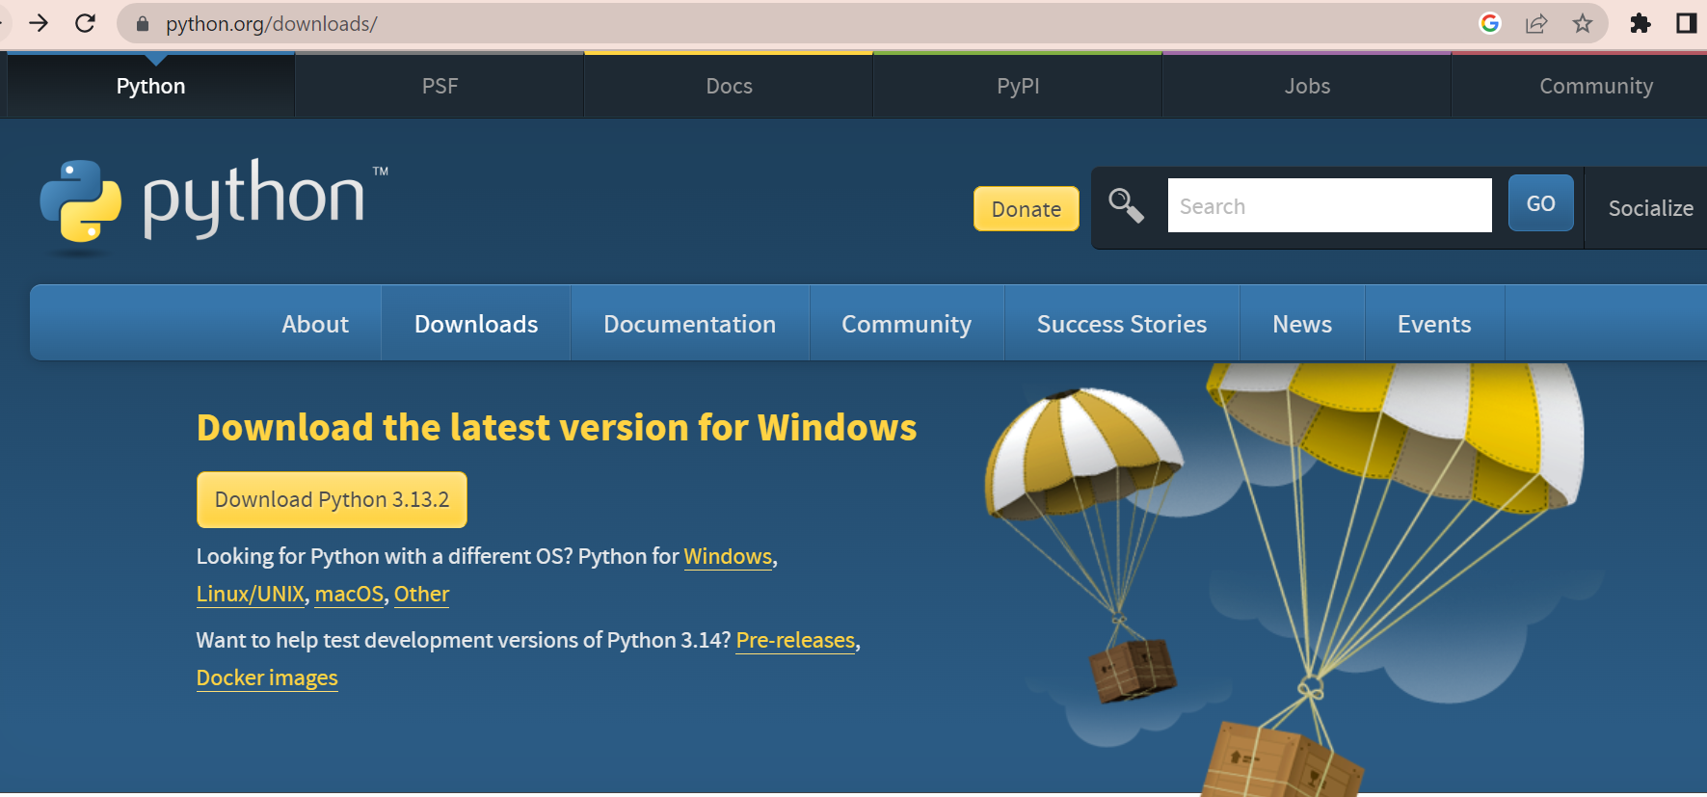

You can download the latest version of python for any operating system and install them.
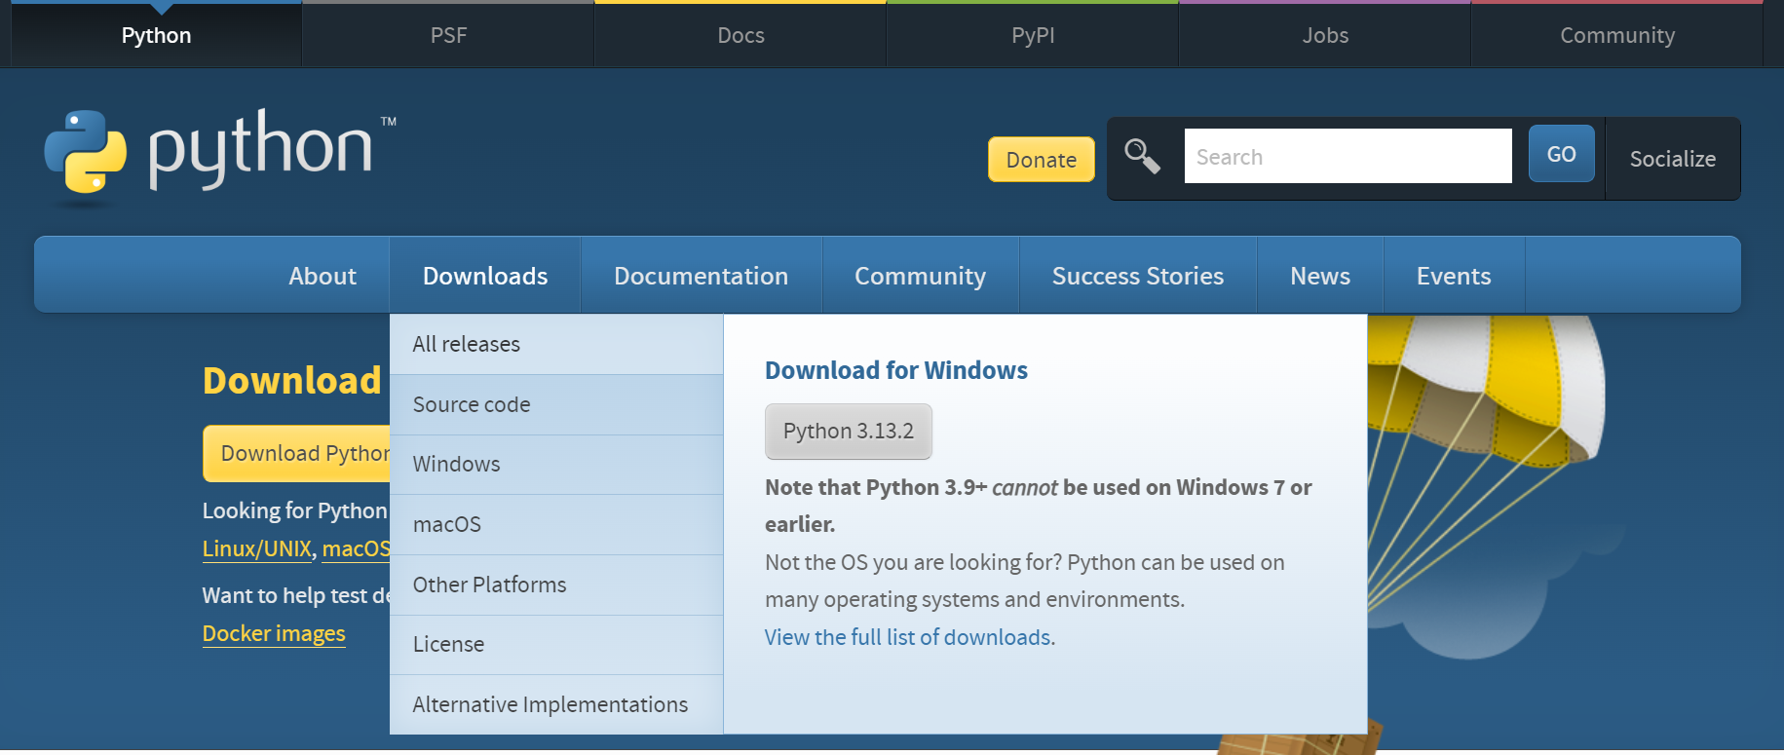

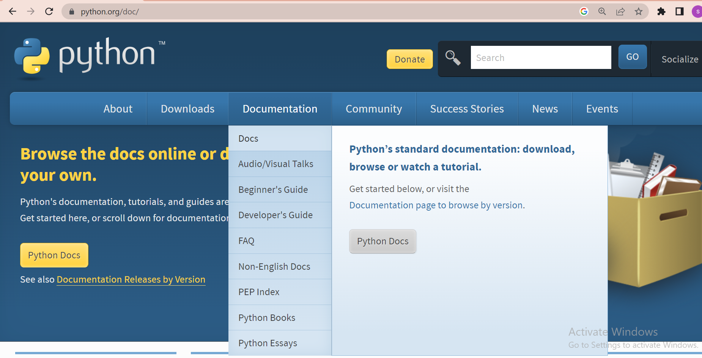
Python Documentation acts as a user manualand provides with all the required information about python including tutorials.Sample of the Documentation page.
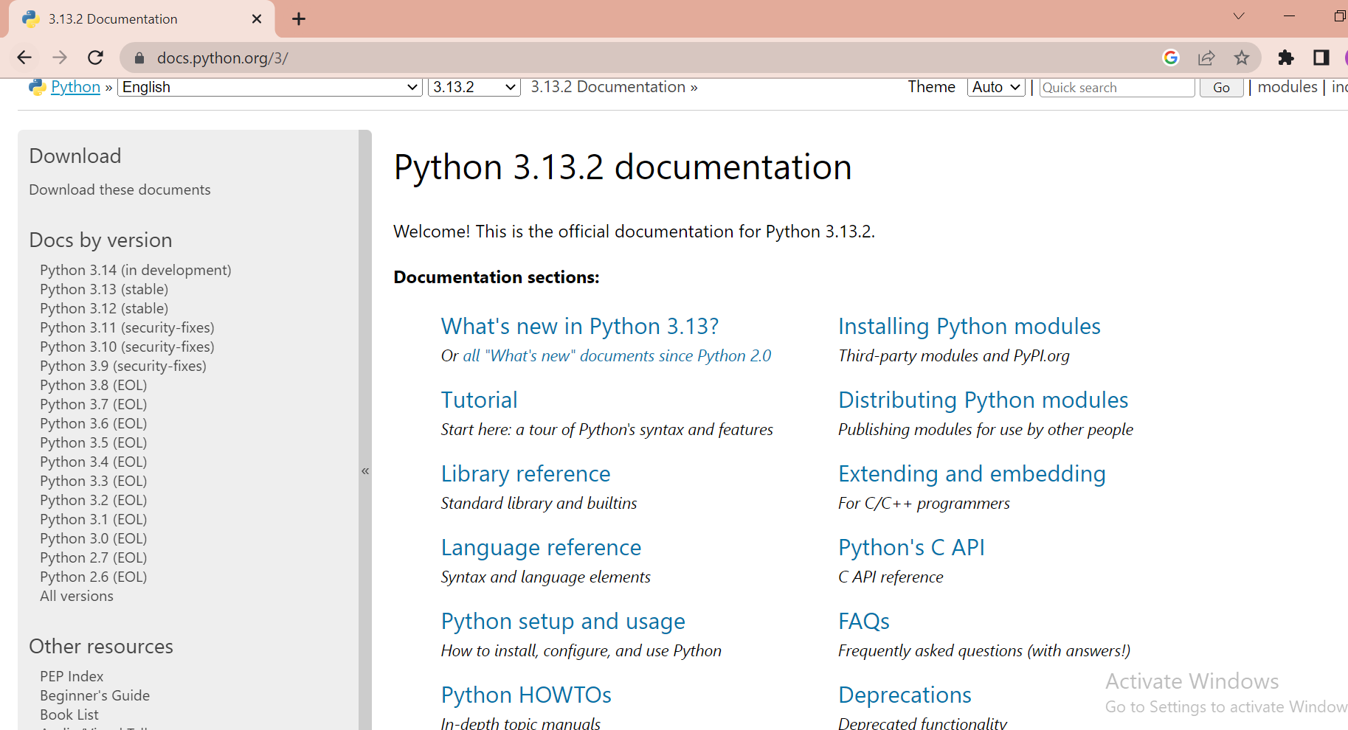
Installing Python on Windows:
- Download the latest version installer for windows from the official website “https://www.python.org”
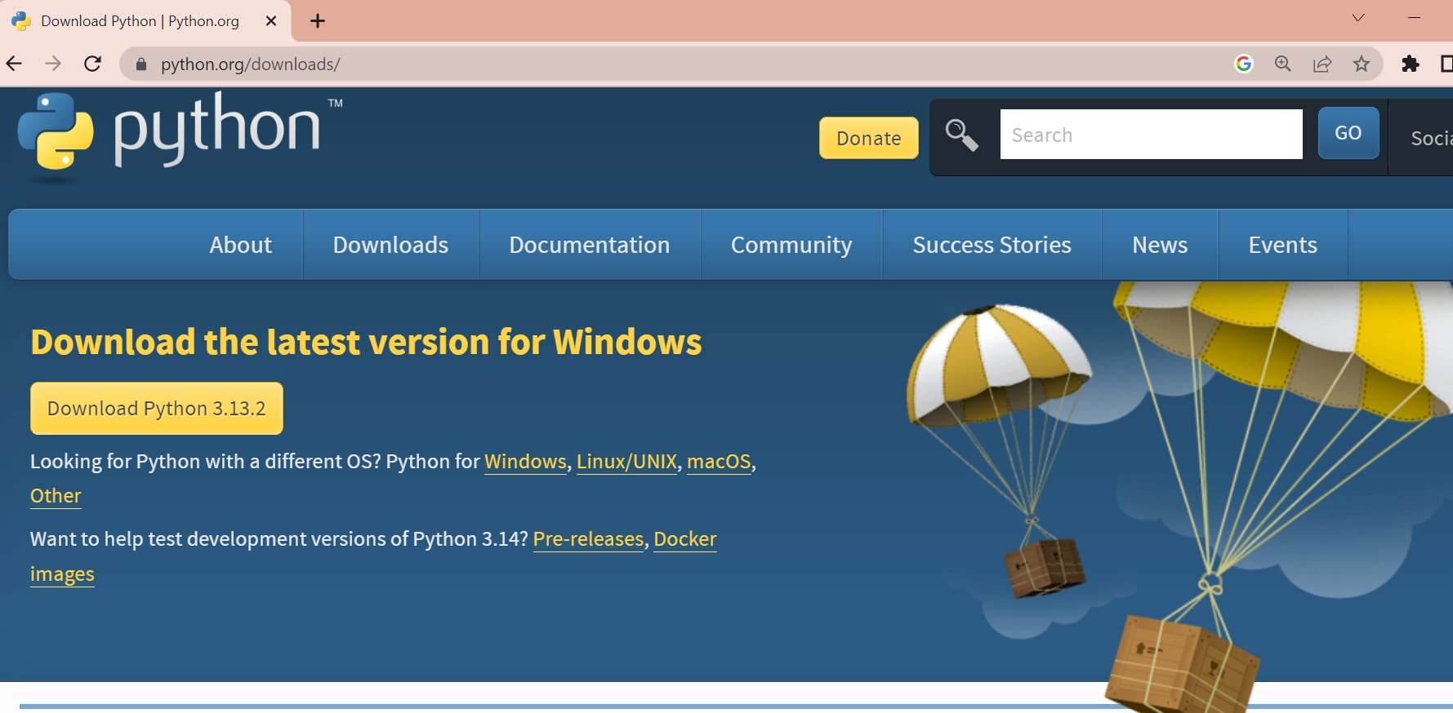
Run the setup
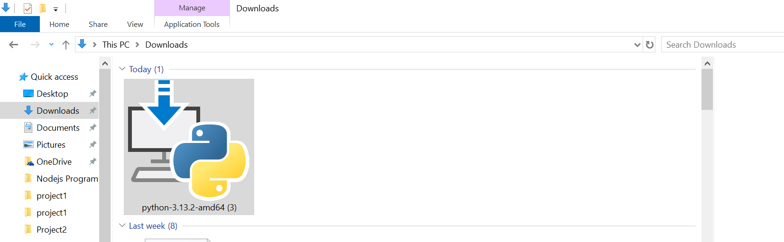
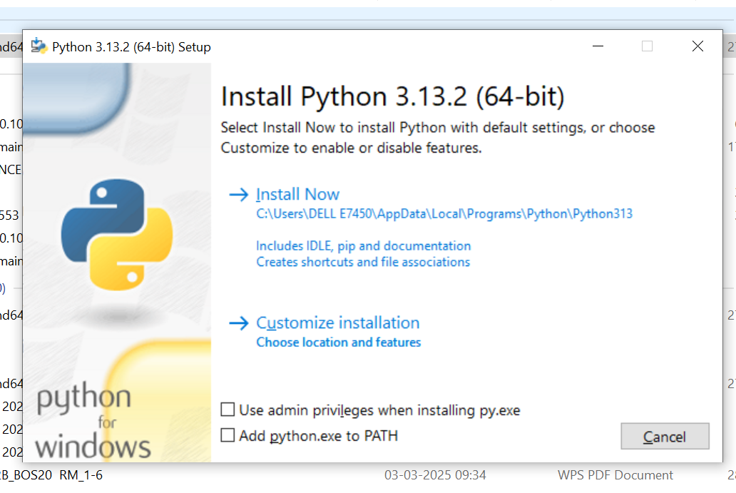

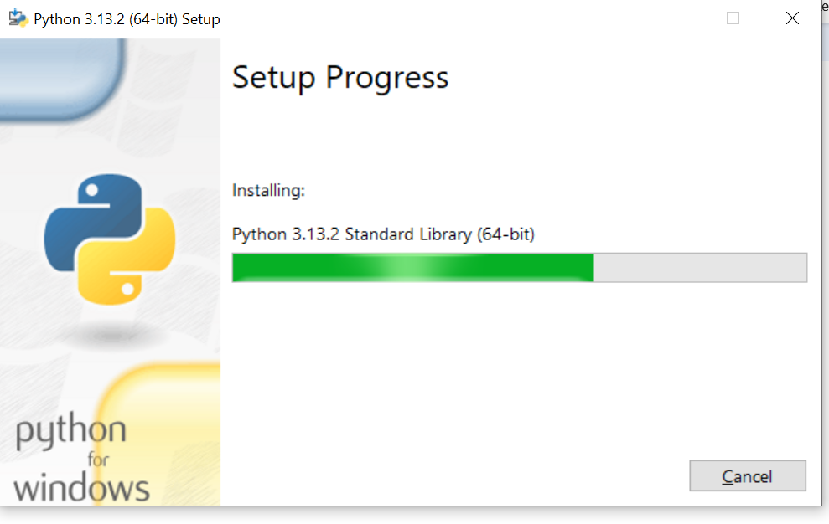
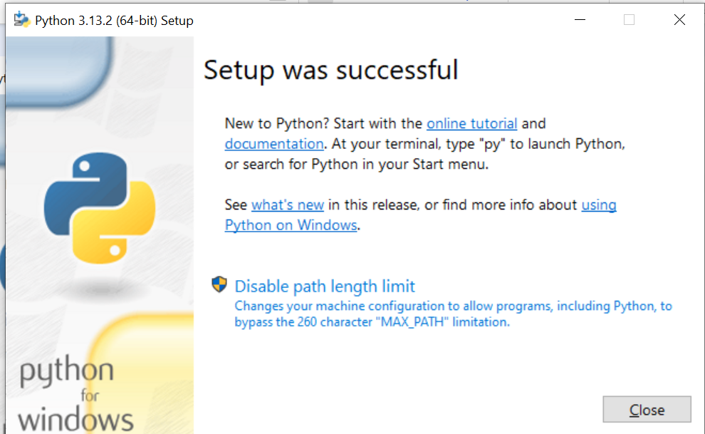

- To start the python interpreter
Go to windows command prompt and type python to run the interpreterc
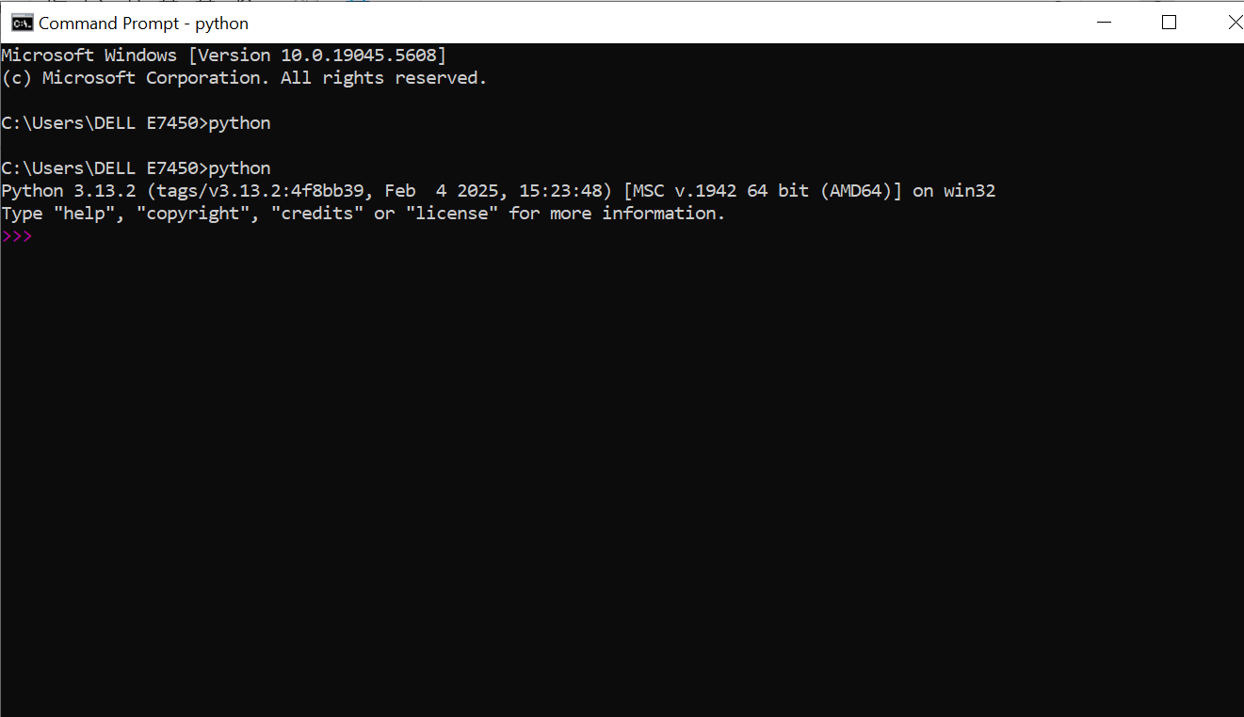
Type help() to start the online help utilities
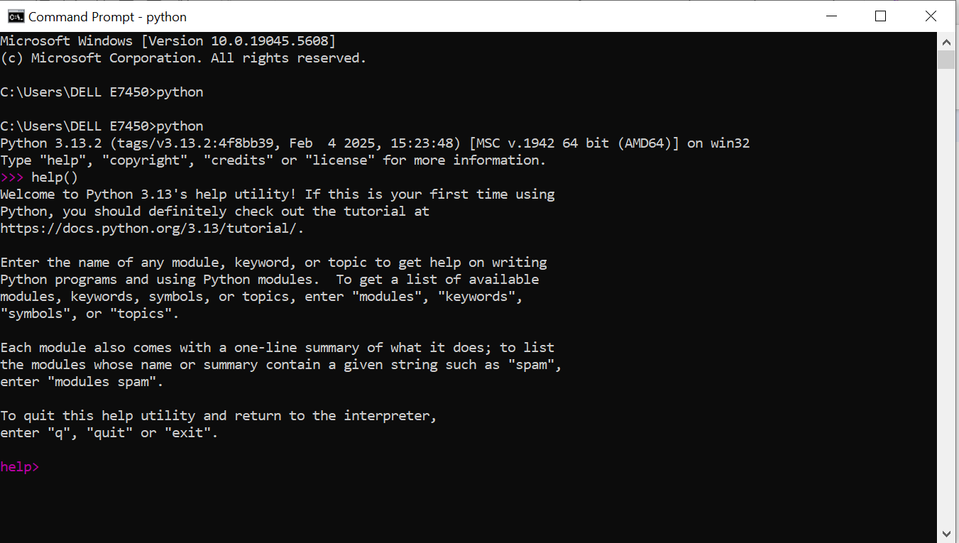
- Start a python Interpreter and use as a calculator
Simple Arthematic calculation can be completed at the python prompt ,also called the python REPL.REPL stands for Read Evaluate print loop the python REPL shows three arrow symbols>>>followed by a blinking cursor programmers type commands at the >>>prompt their bit [ENTER]to see the result.
